**Project Sample Data and Test Conditions**

There are five sample data generated randomly, please upload them to the your distributed system , and you can do the following tests on your two projects:

**一．Distributed Log Query Processing System**

Test1:



Result:

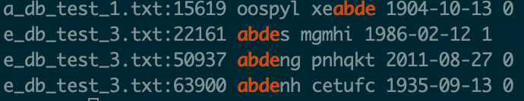

Test2:



Result:

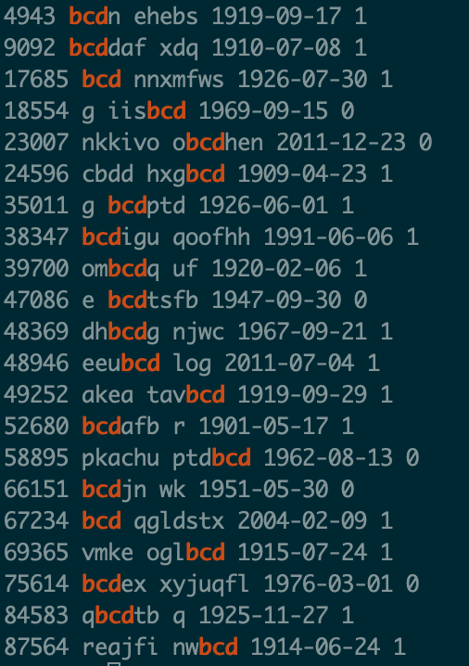

Test3:

When the node storing the file “a_db_test_1.txt” is fail , the system can still run the command



Answer:

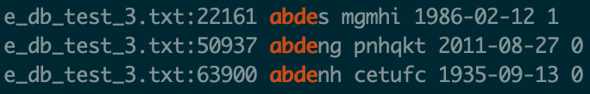

**二．Distributed Group Membership**

**Base Requirements:**

1.A machine (or its daemon) joins the group;

2.A machine (or its daemon) voluntarily leaves the group;

3.A machine (or its daemon) crashes from the group (you may assume that the machine does not recover for a long enough time).

**While you finish the above requirements, you can still run the test in the Project 2.**